The Quantum Milkman
It's the summer of 1985. I'm being driven through the countryside south of Mogadishu, Somalia. Somalia is a land of nomadic people on the horn of East Africa. It is the birthplace of the young woman Arda who has been living with Tom and me in Denver for over a year now. She's learning English and The American Way in preparation for college.
At the wheel on this summer afternoon is Abdi Mohamud Kheyre, Arda's father. Reserved, handsome, intelligent Abdi. He proudly tells me about his homeland as we drive. Today he has taken us to the beach at Merca, for a lobster lunch in a little park restaurant, and for a stop at a town market in Afgooye. He stops the car to let a herd of goats cross the road. A few miles back, it was for 2 tall slender Somalis with their spears and camels.
Sitting next to Abdi in the front seat is Arda's mother Hawa Hassan. She's a stately woman dressed in her colorful Somali 'dirac' robes. A similar bright 'shaash' is draped over her head according to Somali custom for a married woman. Hawa is laughing and talking, her smile flashing out often. She's wearing an abundance of Arabic gold for the occasion. In Somalia, being skinny is a sign of poverty. So Hawa's size is a tribute to her husband's wealth and standing in the community.
In the back seat, Arda is translating the proceedings for me. Farxiya, Hodan and Sam-Sam, 3 of her younger sisters entertain themselves or gaze out the window. Suddenly, one of them yells, "Nirig! Nirig!" I don't need Arda to translate as I look out and see Baby Camel nursing under its mother.
I'm hopping up and down with excitement as Abdi pulls the car over. I get to see Baby Camel . . . up close and personal! The camels are some distance off the road to the left of us. Baby Camel looks like a cross between a teddy bear and a baby deer with its long wobbly legs and its fuzzy caramel-colored coat.
The little girls have charged ahead with Hawa leading Arda and me bringing up the rear of the parade. Abdi decides to stay in the car for a well-earned catnap. Mother Camel is tied to a tree. Baby Camel is now huddled behind its mother, its meal interrupted by our explosion into its quiet afternoon.
I am within fifty feet of the camels when a shout and sudden movement from the right stops me short. I turn to see a very hostile bear-chested Somali nomad with a spear in his hand headed for me. I freeze. I see that he has come out of a hut. I am obviously in someone's front yard and he's mad. I had a terrible sinking feeling in the pit of my stomach. (I knew that many Somalis had a well founded hatred of foreigners.)
The little girls had huddled behind Hawa. By her utter silence, I knew she was as shocked as I was. Hawa started talking quietly, making her way towards me. His hostility only increased. The combination of rich, big city Somali woman and foreigner just intensified his anger. He's shaking his spear now.
Then Hawa stopped in midstream. Her head went forward as she peered at him. Then she burst out laughing. "Ahmed! Ahmed! Hawa! Hawa Hassan!" He looked startled. "Hawa? Hawa Dhanane?!!" Then I saw the look of recognition in his eyes and watched it spread to his body. He lowered his spear. His whole demeanor softened. He smiled and laughed. He and Hawa hugged in the traditional warm Somali greeting. Just like old friends, which is what they were. Turns out that Ahmed had delivered fresh camel milk to Hawa for years when they lived in their old home in another part of Mogadishu.
So here we were. Standing in the front yard of Hawa's milkman. Ahmed glowed as Hawa bragged that he had the best camel milk around. And of course, being the best camel milkman around, Ahmed generously offered us all a drink of fresh warm camel milk. Arda warned me that it's better when it's aged a little . . . kind of like buttermilk. But I was just getting my knees back and was grateful for Ahmed's gesture of kindness. I was more than willing to swallow a little weird tasting camel milk, silently thanking whatever had placed us in the yard of Hawa's milkman.
Ahmed and Hawa chatted. Hawa the socialite filled in the country milkman on their friends in the old neighborhood. I really wanted to cuddle Baby Camel, but under the circumstances, I was satisfied to just edge my way closer, squat and smile at it. Baby Camel didn't look like it wanted to be petted anyway.
Pretty soon, we thanked Ahmed and made our way back to the car. We woke Abdi who had missed the whole drama. As the little ones were getting in, I looked back. The scene was once again tranquil. The only difference was that now I saw a bigger picture. Mother and Baby Camel were part of a little homestead that included Ahmed's hut.
I remember that I wanted to see the energy of what had just happened. I wanted a Slow Motion Energy Camera to show me the love-hate-love cycle. I wanted to see what the energy of delight looks like when it's attacked by fear and turns to fear. What does fear look like when confronted with overwhelming, unfrightened love? What does the energy of fear look like as it dissolves into laughter?
I'll never forget how fast things changed when Hawa recognized Ahmed. And when Ahmed suddenly realized that the enemy was an old friend.
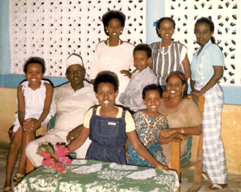
Arda's family in the garden of their Mogadishu home, 1985.
Left to right standing: Deeqa, Sahra, Arda
Seated: Ayan, Abdi, Farxiya (kneeling) Mohamed (on Hawa's chair), Hodan (on Hawa's lap), Hawa
The Energetics of a Quantum Event
I can now understand the energy of that event. We don't yet have the slow motion energy camera that I want. But I'm sure we'll have one within a few dozen decades (to borrow a Jean Houston phrase). Quantum and chaos have explained the energy dynamics to me.
To me, it looks like this.
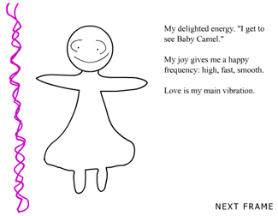
The emotions of this model are simplified. The two most basic emotions are love and fear. (Some say there is only love and the absence of love. This energy will be explored further in Chapter 7: The Big Questions.) For the purposes of this chapter, emotional energy is simplified. It's all variations on the theme of either love or fear. Seen in this light, the energy in the Somali scene snapped from love to fear, and back to love.
How would quantum physics explain this non-physical energy event? Where does Ahmed's fear vibration go? It is energy, so it doesn't disappear or evaporate. (Remember First Law of Thermodynamics: Energy is neither created nor destroyed, only changed.) Is it dissolved and dissipated out of the system of Ahmed? Or is it simply overwhelmed and pushed into a minor vibrational status within the system? Where did my love go when assaulted with Ahmed's fear? Did it leave my system? Or did it get overpowered and become a minor vibration? Can we learn to increase love energy and decrease fear energy - permanently? Can we learn to hold love energy in the face of the strongest fear? How? And when equal power (amperages) of love vibration and fear vibration are face to face with each other, what happens? (Explored further in Chapter 7: The Big Questions.)
And what do the energetic frequencies of love and fear have to do with quantum, anyway?
To answer that, I went back to the beginning: The definition of quantum and what makes a quantum event.
Quantum comes from 'quantity'. A quanta is a quantity, an amount. It is a unit of measurement. Energy measurement. It is the smallest amount of energy we can measure. It's the amount of energy used when an electron moves from one energy orbit to the next energy orbit inside an atom.
Quanta Model
This model shows an electron jumping one quanta up and one
quanta down as it spins around the nucleus.
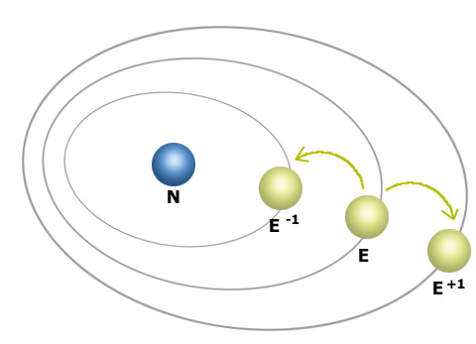
N = neutron
E = electron
E -1 = electron minus 1 quanta of energy
E + 1 = electrón plus 1 quanta of energy
When the electron loses 1 quanta of energy, it goes down one ring. When the electron gains 1 quanta of energy, it goes up to the next ring.
But the really strange thing about quanta which has given rise to the whole strange world of quantum is how it makes this movement. It does not travel through the space in between the two rings. It leaps, instantaneously. Now you see it. Now you don't. It's here. Then it's there. And there's no halfway point. You can't have ½ a quanta, just like you can't have ½ an egg.
In Newtonian Physics, we can watch X move as it goes from A to B.
Newtonian Linear Travel
Quantum Non-linear Travel
But in quantum, X goes from point A to point B without covering the ground in between
This is what a quantum event looks like at a sub-atomic level. Quantum travel is a 'Beam me up, Scottie' type of travel.
In terms of the chaos cycle, what happens at the explosion point can be seen as a quantum non-linear event. One moment the system is in maximum chaos. The next moment the system is in order. One moment you're in total turmoil. The next moment you're in calm. At the explosion point, all the tension releases and suddenly . . . you've moved miles (or light-years) from where you were. Your system's relationship to the issue/new information that was upsetting it has snapped. The anxiety is gone - replaced by a new way of seeing the issue or even a total disinterest in it. The problem isn't a problem anymore. The system has leaped beyond the issue. The issue itself rarely changes. It's still there. But the system has changed and the old issue just doesn't cause you any grief now.
And you're not aware of how you got here. Can you turn around and retrace the steps? Can you cover the ground between where you were at explosion point and where you are now? You've gone from point A to point B without traveling through the distance in between. You have simply arrived. The non-linear pop.
Energetically speaking, change can happen in a Newtonian way or in a quantum way. Newtonian change can be tracked. You see the cause and effect. The cycle itself (of chaos-order-chaos-order) is a Newtonian cycle. We can predict that an orderly living system left alone will go into chaos. And we can predict that an uninterrupted living system in chaos will find its way to order. The cycle itself is predictable. As a matter of fact, Nassim Haramein (more on him later in this chapter) says, "It's not really Chaos Theory. It's Order Theory." It's about chaos that always resolves into order. If we can see the chaotic picture big enough, there's always order there.
So the chaos cycle itself is Newtonianly predictable. However, within the Newtonian cycle is the quantum event: the unpredictable that happens at the explosion point. The system takes a non-linear jump and arrives somewhere else without covering the ground in between.
At the explosion point the system either looses energy and falls apart or gains energy and reforms. In transformation, it comes together in a way that incorporates more energy.
Every time you transform, you
(1) drop deadwood
(2) add energy
(3) add complexity
Every time you disintegrate, you
(1) loose energy
(2) loose complexity
Transformation is a jump to a higher vibration. As separate things come together and bond as a new system, new energy is added to the system. The system now contains more and higher frequencies than before.
Disintegration is the drop to a simpler energetic state with fewer and lower frequencies. The units of the system have splintered and disconnected from each other. They've lost their bond and scattered apart. Disintegration is a move towards isolation and separation, towards a more basic form with fewer options.
A Wrinkle in Time
How does it help to know this: that it is within the Newtonian process that the quantum leap event happens at the explosion point? The key question still is: Is there anything we can do energetically to hedge our bets in favor of transformation instead of disintegration? Can I better answer that question by knowing that the quantum event happens inside the Newtonian process?
Remember from Chapter 3: it is the choices we make during the cooking time that set the history of the organism. That history is the energetic pattern that takes effect after explosion. It is that pattern, that web of strong energy that can draw the scattered pieces back together to form the new more complex system. . . or the lack of a strong energetic pattern that allows the system to disintegrate.
That energetic pattern is the system's memory. A memory is a web of energy, non-physical and real. When the frequencies of the energy web are strong, it can attract new matter to it as well as the old pieces of matter that still resonate with it. This is why the newly formed system has more energy and is more complex. It has attracted to it new matter that matches its vibration. This makes a physical system similar to the former system that scattered at the explosion point. Except it's better, energetically speaking.
• The energetic web of memory is formed during the cooking time. (Remember that the cooking time is how you react when the ERI comes into your system and disturbs it.) The energetic web has attracted and solidified matter to it, so it has material substance. The matter attached to it can be everything from the body's toxins to a muscular usage pattern. The belief patterns have become physical. They are now attached to the energetic web. For example, the belief that "I'm sick and weak and I can't handle this disturbance" becomes a chunk of S toxins that hook onto the energetic web, making it rigid. The belief "I'm basically strong and resilient and I can handle this emergency" becomes a piece of B endorphin-like matter that attaches to the memory's energetic web, making it stronger.
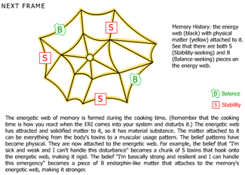
An example of this memory energy cycle is on your own skin. Think of a wrinkle you have. If you don't have a wrinkle (wow J), think of a mole or scar. Any skin blemish will do. What keeps that wrinkle in your skin? It's not your skin cells. They die and are replaced every 30 days. Every month you get fresh new skin cells on that skin blemish. So if I have new skin, why do I have an old wrinkle? (Other than to fund the billion dollar cosmetics industry, that is.)
Why do I keep the wrinkle? I keep the wrinkle because of my skin's memory. There is an energetic web of memory that draws the new cells into the old form. New cells in the old wrinkle. Darn!
The cycle looks like this: This is a wrinkle (greatly enlarged). As seen from the side, it looks like the Grand Canyon.
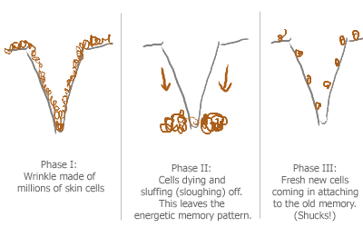
The energetic memory pattern is especially important after the explosion point. If it's strong enough, it creates the field that attracts parts back to it to form a new system. When it's strong enough, the system trans-forms. It takes on a new form at a higher more complex level.
An energetic memory pattern is a belief. A belief is formed when you repeatedly accept something as true. Repeatedly doing something or believing something makes it into an energetic memory. That energetic memory then locks the system's body into a reality based on that belief. "Seeing is believing" has it backwards. It's actually "Believing is seeing." When you believe something, that is what you will see. Your energetic belief is attracting what you then see as reality. Sad but true: It is our belief that we are aging that attracts the wrinkles that then confirm that. Have you ever seen an old person who ought to have wrinkles and grey hair but doesn't? (And not because they've been surgically sucked, tucked and tinted.) Keep your eyes open. They're rare, but they're out there.
Since our mind creates the pattern, can we undo the pattern the same way? By believing something different? Of course. But how?
CHANGE BELIEFS & CHANGE THE SYSTEM'S HISTORY
The brain has a nifty device. It's called the Reticular Activation System, or RAS for short. It's our belief-maker and our belief-breaker. It can help us change beliefs. Beliefs create actions which create history.
Beliefs > Actions > History
So when we change our beliefs, we change our history. By changing our history, we may hedge our bets in favor of transformation at explosion point.
The way the RAS works is simple. It screens all the information coming in to the brain. Our five senses give us thousands of bits of information every second. This much input would overwhelm us, so the brain screens most of it out. Less than 1% of this sensate information actually gets through to our consciousness. Good system. But what decides which information gets through?
The RAS lets through only that information which agrees with our beliefs. The information that does not match our beliefs doesn't make the cut. For example, have you ever bought a new car? You've looked around, compared, and narrowed it to 2 kinds of cars: a Ford Mustang and a Saturn. You decide on the Saturn and you buy it. Now, you start noticing Saturns everywhere. This is not because there are suddenly more Saturns in the world. It's because you have decided that Saturn is a good car. You've reprogrammed your brain and opened your RAS to Saturns. Your RAS will now let through all the Saturns in your environment.
Paradigm is another word for a pattern of belief. Joel Barker is well known for his groundbreaking work with paradigms. His books and corporate training videos are excellent. (See Paradigms, Paradigm Pioneers and Future Edge) His research shows just how strong the effect of the RAS is. His work is further proof that only that material that agrees with what we already think gets through. Said differently, we literally do not see, hear or receive information that does not agree with our beliefs. If I believe the earth is flat, I will not receive any information to the contrary. If I believe Republicans are good and Democrats are bad, my RAS will only admit information that supports that. If I hate Moslems (or Christians or Jews), then my RAS will only give me facts that justify my hatred. If I believe the world is a frightening violent place, that's the information I will continue to get . . . unless I reprogram my RAS.
This is a model of how your RAS works. It acts like a funnel. All sensate information (sight, sound, taste, touch, smell) comes into the funnel. It goes down the side in little chunks. The RAS robot sits by your library of programs. When it sees a chunk of information coming that's about men, for example, it finds your program on "Men". It plugs it into your RAS computer. The trap door opens. Everything that is contrary to what you believe about men drops through the trap door into the depths of your unconscious. Only the part that agrees with what you already believe about men will get through to your consciousness
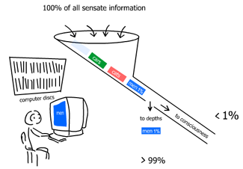
The RAS supports your beliefs
Specifically, it looks like this. It's Monday morning after Mother's Day. You are on break with your female colleagues. Sarah says, "Juan did the sweetest thing for me yesterday. . ." Ramita says, "You know, I just can't figure out how a husband of 15 years thinks a toaster is a great Mother's Day gift!" If you believe that men are thoughtful and caring, you'll hear Sarah's comment, take it up and add your own. If you believe that men are inconsiderate jerks, who are you going to hear? Your ears pick up the sounds of the entire conversation. But your brain will register only the part that agrees with your program. Unless you reprogram your RAS.
Reprogramming the RAS is simple. That's the good news. You simply make the decision to let in new information, and tell your RAS to open up to something new. . . and really mean it. (I said simple. I didn't say easy.) For example, if you're a woman who thinks men are jerks, you tell yourself that you want to change how you feel about men. You tell your RAS that you want to get a balanced objective view of men. You tell it to let through ALL the information about men. If you're a Christian who fears Moslems, you tell yourself you want to get to know some friendly Moslems and learn about Islam. If you've always been a Democrat, tell your RAS you want to open up to receive the valuable views of Republicans. If you had an alcoholic father and hate being around people who drink, tell your RAS that you want to learn to be comfortable around people who are responsible drinkers. If you really mean it, the RAS will do the rest. And you're on your way to creating a new history for yourself which will give you new results when the next crisis/chaos jolts into your life.
In order to experience something different, you have to choose to open up to a new way of seeing, to a different reality. This different reality may convince you that your previous reality no longer serves you, even though it did serve you until now. Remember nature's question: Does it benefit the system?
If you decide that a new reality works better for you now, then you have to create a new memory for your cells to form around. You do that by making choices consistent with the reality you want until it becomes a pattern. The new pattern must become stronger than the old pattern before the old pattern dies. Technically it doesn't die since energy is never destroyed. The new pattern simply overpowers the old pattern. The old one may weaken due to starvation because you're not feeding it any new energy. It may scatter and move someplace else outside your system. (In Chapter 6, Toolbox for Transformation, there's more on how to do this.)
Consciousness
There's an exciting new theory in the quest for the Unified Field. Briefly, the Unified Field Theory (or the GUT, the Grand Unified Theory) is the search for the missing energetic link. Science tells us there are only 4 forces. They are:
- gravity
- ELM or electromagnetism
- weak nuclear force
- strong nuclear force
No one to date has been able to explain the energetic link that ties them all together. Including Einstein. He spent his later years tearing his hair out in search of the unified theory. (Hence, his hairdo!)
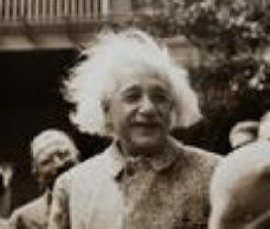
Einstein with his Unified Field Theory hairdo
I've been mildly intrigued with the search for The Unified Theory for years. I was moving into Becky's (now my) house in December, 2000. We had a most interesting conversation about a scientist she'd just spent some time with in California. His name was Nassim Haramein. He said he'd proven that the unifying force was (TA! DAH!) Consciousness. I remember the explosion going off in my head when Becky said, "consciousness." I remember thinking, "BAM! That's it! Of course. Makes perfect sense. How else could these wildly different forces become coherent with each other, except through consciousness?"
At the time, I got Nassim's contact information from Becky. But it was almost two years later before I contacted him.
As I was in the process of reaching Nassim, I was searching for a definition of consciousness. The best one I've found (my own) is:
Consciousness is
awareness of
connection to the whole
For example, healthy cells are conscious because they communicate with the whole body and know their function within that whole. Cancer cells aren't conscious because they don't know their connection to the whole. They have walled themselves off into a false community, the proliferation of which kills the host. A person who litters is unconscious because they are fowling their own nest. They don't understand their connection to the whole community. And a person who has been knocked unconscious with a blow to the head is unaware of their connection to their body, their physical surroundings, etc.
Conscious Choice or Unconscious Reaction?
What does it mean to make a conscious choice, in terms of a living system? What does it mean to unconsciously react?
A little scenario came my way a few months ago that helped me clarify this. It was early on a quiet Saturday morning. I was walking to the back yard to pick some Hibiscus flowers for the day. As I passed the cabana, I saw that the bike was gone, so Megan had already left for work. Then I noticed that the refrigerator and freezer doors were open. Odd. That's not like Megan. I went in to close them ... and went into shock. The cabana had been ransacked. Clothes were thrown everywhere. Drawers were pulled open. The closets were open. All the kitchen cabinets were open, and food and dishes had been moved to the desk.
I stood in the middle of the cabana, breathing. "OK, calm down. No one's been hurt. There's no blood. There's no violence. Nothing's been broken or smashed. Nothing's permanently ruined." As I got calmer, I noticed more. Nothing had been taken. The CD player was there. No damage to the computer. I didn't feel like whoever was here had been angry and violent, or intent on destruction. If they weren't stealing things, were they just after money? Had they taken anything from Megan?
It was a very creepy feeling to know that someone had simply walked into my cabana in broad daylight and wreaked havoc. I felt scared and invaded and defenseless and mad.
I got in the car to go tell Megan. I wanted to tell her in person rather than on the phone. Also I realized I was shook up, and I really wanted to be with a friend. As I was driving I asked myself, "Why am I scared? What am I afraid of?" It boiled down to 2 things: First, I was afraid that this would happen again. That this was an indicator of 'increasing violence'. I'd have to call the police -- deal with an investigation in my bad Spanish or their broken English. I was afraid now that someone had broken in, some undesirable elements would think that I was an easy target, etc. Bottom line, that I would have to do something to increase my protection: get guard dogs, put in a security system, put locks on the gates, build a wall around the yard . . .
Secondly, I was afraid that Megan would feel scared and move out . . . that I would lose her as a friend and writing assistant. I pulled up to the garden at the Ann Wigmore Natural Health Institute where Megan was working. I decided that in addition to telling her what had happened, I also needed to tell her I was afraid she'd want to move. It's my way of facing fear: put it in words.
Megan is one in a million. When I told her that her apartment had just been ransacked, she was totally calm. She said, "You know, about ten minutes ago, I was working with the soil. I was on my knees, running the rich compost through my fingers, and I was thinking, 'The most important thing to me in the world is this earth. Nothing matters more to me than this.'" She didn't even say, "I wonder if they took my money." I had to ask her if she'd had any cash anywhere. (When I got back to the cabana, her money was still there.) When I told her I was afraid she'd move, she laughed and said, "I like it there. Why would I move?"
I called my friend Charlie to talk over whether I should call the police. (And for comfort. I was still feeling alone and vulnerable.) Charlie told me that his son's shop, the Taino Divers, had recently been hit in the same way: nothing taken or broken, just thrown around. The police said it was a local crazy woman. "She's harmless. She just wanders into places and liberates whatever's in drawers, cabinets, refrigerators. Doesn't like to see things closed in."
I cleaned up the cabana and called Luis to come put a lock on it.
When I'm in chaos, it helps me to think in terms of conscious choice instead of unconscious reaction. The difference looks like this.
Unconscious Reaction:
~ fear-based: I'm in trouble.
~ knee-jerk response: Call the police.
~ it's about security: I've got to protect myself.
~ small system approach: They're after me.
~ blame: Find the offender and punish them.
Conscious Choice:
~ trust-based: I'm OK.
~ thoughtful observation: What are the facts? (objective, unemotional)
~ it's about information: There's a message here. What is it?
~ big system picture: What's happening in the larger system?
~ responsibility: What's my part of the problem that I can fix?
(Like, how about putting a lock on the door, Phyllis.)
WORKSHEET
Think of a problem you have had recently. What was the problem?
_______________________________________________________________________
_______________________________________________________________________
_______________________________________________________________________
What would have been an unconscious reaction to the problem?
_______________________________________________________________________
_______________________________________________________________________
_______________________________________________________________________
What would have been a conscious response?
_______________________________________________________________________
_______________________________________________________________________
_______________________________________________________________________
What is a problem you have now?
_______________________________________________________________________
_______________________________________________________________________
_______________________________________________________________________
What is an unconscious reaction to it?
_______________________________________________________________________
_______________________________________________________________________
_______________________________________________________________________
What does a conscious choice look like?
_______________________________________________________________________
_______________________________________________________________________
_______________________________________________________________________
Every decision is an option between an unconscious reaction and a conscious response. As we become aware of our unconscious patterns, we can change how they affect our life.
Back to Consciousness, The Unified Field Theory, and Nassim Haramein. When I reached Nassim, he had moved to Hawaii. We had a great conversation on the phone. The high points went something like this. (It's not important to understand the finer scientific points here. Just get the main ideas.)
Phyllis: How in the world do you quantify Consciousness as a mathematical concept?
Nassim: Seeing it as a fractal open feedback.
P: And you've mathematically proven that Consciousness is the unifying force?
N: Yes. I use fractal geometry. I plot the radius of a system vs. its fundamental resonance frequency, obtaining a space-time scaling law from universal size radius to subatomic particles - describing them all as different scale black holes. Everything on the graph generates a smooth line continuum, from macro to micro. The theory is extremely accurate with its predictions. Each scale level is considered as a resolution in the fractal geometry of spacetime, and if we plot the average size of a human being on the graph, the data point just happens to fall exactly at the center of the graph between universal size and subatomic. I thought that was sweet, because my theory describes us as an event horizon between infinitely big and infinitely small, and using fractals, which are open feedbacks, I describe self awareness, which demands a feedback of information.
P: What about weak and strong nuclear forces?
N: They don't exist. Scientists just pulled those out of thin air. I can prove there's no such thing. There's only gravity and ELM. The so-called strong and weak force of the subatomic world are just the result of the mini black holes interacting.
The problem has been that we've tried proving stuff with Euclidian plane geometry. It's an aberration because there's no such thing as a flat 2-dimensional plane, so any physics using Euclidian axioms is screwed. If you put fractal geometry into 3-D space, it comes out correct. If Einstein had had fractal geometry, he probably could have solved gravity. The whole biosphere expresses fractals. Space-time is embedded with fractals.
And with order. That's another concept they've got wrong: Chaos Theory. It's not Chaos Theory. It's Order Theory. There's order at the core. The heart of the Universe is order.
P: Have you gotten any support for your work, your theory? Do you have any endorsements?
N: I've presented it twice to the APS (American Physical Society), with the support and the help of Dr. Elizabeth Rauscher, amongst others. The APS is the largest physics society on earth. Dr.Rauscher is a very accomplished physicist who worked on black hole theory with some of the greatest physicists on earth. She's published over 300 papers. Some of the ones she published in the 60's and 70's were approaching this new theory. So I am gaining more and more support from the mainstream physics community.
But if you're talking about financial sponsors, I am definitely ready for a new level of sponsorship which this work demands. Through the years, I have had many sponsors, but at this time I am on my own. My team and I are dedicating all of our time. I'm hoping that the publishing of my upcoming scientific papers and book for the layman will help that side of things. It's extremely exciting stuff, and it will replace the current paradigm of physics. Typically those big changes are done with modest means and by somewhat isolated individuals.
P: Where can I read your material?
N: My book, Crossing the Event Horizon will be published sometime in 2003. The event horizon is where there's the balance between ELM pulsing out and gravity pulling in. The scientific papers are now being reviewed, and will be published in peer review journals soon. It's pretty controversial. But then, every significant change in physics was thought to be controversial before it became the norm.
As I ended my fascinating conversation with Nassim Haramein, I thought of what Max Planck had said about new ideas.
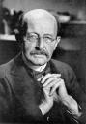
Max Planck
Max should know about new ideas, being the inventor of quantum theory. If any one person could be given that title, it would be Planck. In 1900 while only 22 years old, he devised the formula that renounced classical physics and introduced the quanta of energy. Max Planck's biography says, "At first the theory met resistance. But due to the successful work of Niels Bohr in 1913 (calculating positions of spectral lines using the theory), it became generally accepted." Planck received the Nobel Prize for Physics in 1918.
Max Planck said,
"A new scientific truth does not succeed
because the opponents are convinced
or (. . .) educated.
However, they die and
the new generations learn about it
from the beginning as the truth."
It's interesting that it took a couple of generations for quantum theory to become accepted. One way for a new truth to take hold is to wait til the Old Guard dies, as Max Planck says. Let the next generation grow up with the truth.
But there's a faster, easier way. It lies in the wisdom of Yoda. It deals with our own power over our own brains using the RAS and the intention to be open to new truths.
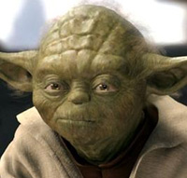
"You must
UNLEARN
what you have learned."
-- Yoda
Consciousness in Chaos
I have a confession to make. I don't like chaos. I like order. I like peace. I like tranquility. I'm working on finding a way to stay there. But I know that what my friend Charlie says is true:
In my little world
of peace and tranquility
. . . lurks atrophy!
~ Charles E. Carson
So I want to stay peaceful in a healthy way, not because I'm sunk in the deadly swamp of denial.
If indeed it is order at the heart of the universe, might it be OK for me to be more in love with order than I am with chaos? Might it be OK for me to want to spend more of my life in an orderly system instead of a chaotic system?
So, how do I stay in an orderly system as much as possible . . . and stay open to, aware of, and processing all incoming information so that I don't atrophy? If I can get out of the Newtonian drag (suffering through long periods of chaos) and increase my periods of tranquility, might that be preferable?
To answer my questions, I went back to the chaos model. Think in terms of the KMC from Chapter 3. Click here for the image. What would be a way to shorten the chaos time and still allow the full natural process? Can I move the explosion point to the left, so to speak?
If I get to the explosion point earlier, do I avoid some chaos? How? The system has to build enough chaos pressure to shatter the Tolerance Boundary (TB). So perhaps if I lower my TB, then the system reaches explosion point earlier at a lower level of chaos.
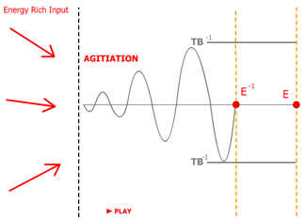
KMC with lowered Tolerance Boundary (TB⁻¹)
and therefore less chaos
and smaller explosion
This must be what they mean when they say, "You can get the message with a feather or a Mack Truck."
Bigger TB = bigger explosion = Mack Truck
Smaller TB = smaller explosion = feather
What does a smaller TB look like? How do I create it? Can I consciously choose to have a lower tolerance for pain in my system? If so, can I lower my pain tolerance (my T.B.) without ignoring or repressing the ERI and getting stuck in Stability? Can I have Order without Stability?
A lower TB would come from having an increased awareness of anxiety in my system. Sort of a DEW Line (a Distance Early Warning Line). It would mean: check in with the system more often and more honestly. It would mean: stay alert for any new ERI. Pay attention to how that information affects my system. Ask questions like:
~ Does this information serve me? Is it beneficial? ~ Does it feel good? ~ Does it fit my purpose?
If the answer is "yes", embrace it. That means make room for it, adapt to it and include it.
If the answer is 'no', then there is one more question: Is there something here for me to learn? Tricky question. If your answer is 'no' and there really is something that's beneficial for your system to learn, then you've missed a chance to improve the system. But don't worry, the same information will be attracted to you again for the same reason, and you'll get another shot at it.
You can also decide that the ERI is information that you already know (just dressed up in a different costume). You have dealt with it before and have a place to put it. If you have no reaction to it, then it won't create any initial waves or feedback. If it doesn't create any agitation, then there won't be any chaos. You walk away from it, knowing that it exists and is not important for your system.
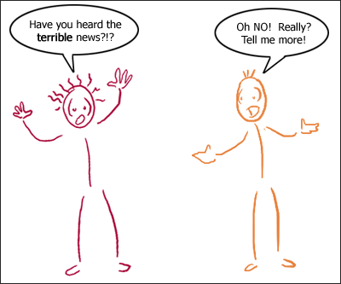
You can buy in to someone else's fear. . .
or...
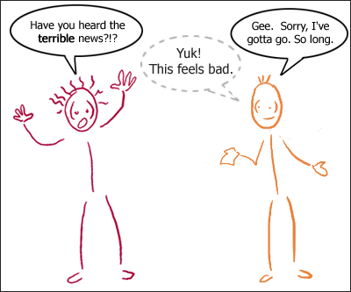
you can walk away from it,
and let them go look
for another negatron to share their fear.
Conscious choice allows us to avoid what we don't want in our system. Avoidance is only unhealthy if the information is beneficial for your system. Alarmist Al thrives on negative Twinkies. If you don't, then don't eat Twinkies with him.
Isn't the reaction in the second scene a denial of reality? Yes. Exactly. It's a denial of Alarmist Al's reality. You say, "Been there. Done that. Don't choose it anymore." Remember. Quantum has multiple realities - literally. You not only have the right to choose yours - you have the delight of choosing it.
I've designed some quantum T-shirts for this.
Quantum T shirts
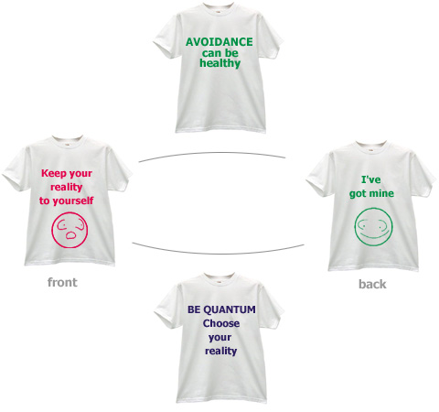
In human systems, the quantum event of transformation can be a result of choices made over a period of time. Your choices create an energetic pattern during the Newtonian cooking time in the chaos cycle. There are two ways that energetic pattern forms. One is by default: something happens, you react . . . something happens, you react, etc. The other way a pattern forms is by choice: Something happens, you make a choice . . . next thing happens, you make a choice, etc.
The pattern that is made takes effect during the quantum event at the explosion point. A default pattern is more likely to move you into isolation, separation, atrophy. A conscious pattern hedges your bets in favor of higher complexity, inclusion and wholeness.
We all have wake-up calls. They are a natural part of the chaos-order cycle. We can invite our wake-up calls to be delivered by a feather instead of a Mack truck. Stay open, be aware, make conscious choices.
Summary Outline
The Quantum Event
I. The Quantum Milkman
A. Rapid change of emotions (delight to fear to delight)
B. Two basic emotional frequencies: fear and love
C. Strong fear frequencies (Ahmed) overwhelm another person's (Phyllis) love frequencies
D. Strong love frequencies (Hawa) overwhelm another person's (Ahmed) fear frequencies
E. Understand the system's change of emotional frequencies in terms of both:
i. Overwhelming a major vibration into a minor status = pushing it down
ii. Magnetizing/entraining a minor vibration into a major vibration = pulling it up
II. The Energetics of a Quantum Event
A. Definition of a quanta: measurement for unit of movement
B. Simplified definition of quantum: jump from here to there without covering the ground in between
C. A "Beam me up, Scottie" type of event
III. Big Picture
A. Chaos cycle is predictable. The cycle itself is Newtonian.
B. The explosion point is quantum.
C. So within the Newtonianly predictable chaos cycle there is a quantum event at explosion point
D. The quantum event at explosion point either:
i. Transforms
1. drops deadwood
2. adds complex frequencies
3. adds energy
4. moves toward wholeness
ii. Disintegrates
1. looses energy
2. looses complexity
3. moves toward isolation, separation, entropy
IV. A Wrinkle in Time
A. Energy patterns are the history of the system - its memory
B. Those energy patterns are created by the choices made during the cooking time of the chaos cycle
C. A skin wrinkle as an example of a cellular memory pattern, also known as a belief
D. New cells nest into old wrinkle pattern because the energetic memory tells them to
V. Change Your Beliefs to Change Your History
A. Beliefs > Actions > History
B. Brain's Reticular Activation System, the RAS
C. RAS is your belief-maker and your belief-breaker
D. RAS screens out overload of sensate information
E. RAS lets in only that which agrees with your beliefs
F. You can reprogram your RAS
G. Tell your RAS to let in more information
H. . . .and mean it
VI . Consciousness
A. Consciousness is awareness of connection to the whole
B. Unified Field Theory – Nassim Haramein:
i. Consciousness is the force that unifies gravity and ELM
ii. There is no weak nuclear force nor strong nuclear force
C. Conscious choice in a living system
i. Trust-based: I’m OK.
ii. Thoughtful observation: What are the facts? (objective, unemotional)
iii. It’s about information: There’s a message here. What is it?
iv. Big system picture: What’s happening in the larger system?
v. Responsibility: What’s my part of the problem that I can fix?
D. Unconscious reaction in a living system
i. Fear-based: I’m in trouble.
ii. Knee-jerk response: Call the police.
iii. It’s about security: I’ve got to protect myself.
iv. Small system approach: They’re after me.
v. Blame: Find the offender and punish them.
E. Example of healthy cells and cancer cells
i. Cancer cells unconscious – not aware of their connection to the whole. . .isolated behavior kills the host/whole
ii. Healthy cells conscious – monitor their behavior based on benefit to or condition of the host / whole
F. Moving the explosion point in the KMC
i. Mack truck = moving the point to the right = longer periods and higher chaos before explosion point
ii. Feather = moving the point to the left = shorter periods of lower chaos before the explosion point
iii. Can we get out of the Newtonian drag of suffering through long intense periods of chaos by changing our behavior during the cooking time? Practices that can support the feather:
1. Stay open to all incoming ERI
2. Stay aware of the effect
3. Make choices that enforce the patterns you want

